**LPG Gas leakage detection system with auto cut off regulator and switch on Exhaust Fan and make alert by buzzer and sending notification by using ESP32**

**Abstract**

*LPG gas leaks pose significant safety risks in domestic and industrial environments. This paper presents an LPG gas leakage detection system using the MQ6 gas sensor and the ESP32 microcontroller to mitigate these risks. The MQ6 sensor continuously monitors the air for LPG presence. When the gas concentration exceeds a safe threshold, the sensor alerts the ESP32 microcontroller.*

*In response, the microcontroller activates an exhaust fan to ventilate the area, reducing the gas concentration and minimizing ignition risks. Simultaneously, a buzzer is triggered to warn occupants of the danger, prompting immediate action. Additionally, a servo motor connected to the gas cylinder regulator is engaged, closing the gas supply to prevent further leakage.*

*The system also features an email notification mechanism. Utilizing the ESP32's Wi-Fi capabilities, it sends real-time alerts to designated recipients, such as homeowners or emergency services, enabling timely intervention.*

*This integrated approach of detection, mechanical response, and remote notification enhances LPG safety significantly. Initial tests demonstrate the system's effectiveness in timely leak detection and response, making it a valuable solution for environments where LPG is used.*

**Introduction**

Liquefied Petroleum Gas (LPG) is a versatile and widely used fuel in residential, commercial, and industrial applications due to its efficiency, portability, and relatively clean-burning properties. Despite these advantages, the leakage of LPG poses significant safety risks. LPG is highly flammable, and even a small leak can lead to dangerous situations, including fires, explosions, and health hazards.

LPG leaks can occur for various reasons, such as faulty equipment, improper installation, wear and tear of components, or accidental damage. The gas is typically stored in pressurized containers, and any compromise in the integrity of these containers or their associated piping can result in a leak. Given the heavier-than-air nature of LPG, the gas tends to accumulate at lower levels, which can create a hazardous environment, particularly in confined spaces.

Detecting LPG leaks promptly is crucial to preventing accidents and ensuring safety. Traditional methods, such as manual inspection and soap bubble tests, are often insufficient for timely detection, especially when leaks occur in inaccessible areas or when the gas concentration is low. Therefore, the development and implementation of advanced gas leakage detection systems are essential.

**Key Components and Functions**

1. **MQ6 Gas Sensor:**
   * The MQ6 sensor is highly sensitive to LPG, iso-butane, and propane. It continuously monitors the air for the presence of these gases.
   * The sensor outputs an analog signal proportional to the gas concentration, which is sent to the ESP32 microcontroller.
2. **ESP32 Microcontroller:**
   * The ESP32 serves as the central processing unit of the system. It processes the analog signal from the MQ6 sensor to determine if the LPG concentration exceeds a predefined safety threshold.
   * The ESP32 has built-in Wi-Fi capabilities, which enable remote monitoring and notification.
3. **Exhaust Fan:**
   * Upon detecting a gas leak, the ESP32 activates an exhaust fan to ventilate the area. This helps to disperse the accumulated gas, reducing the concentration and minimizing the risk of ignition.
4. **Buzzer:**
   * A buzzer is triggered to provide an audible warning to occupants, alerting them to the presence of a gas leak and prompting them to take immediate action.
5. **Servo Motor:**
   * The system includes a servo motor connected to the regulator knob of the LPG cylinder. When a leak is detected, the ESP32 sends a signal to the servo motor to rotate and close the regulator, effectively shutting off the gas supply and preventing further leakage.
6. **Email Notification:**
   * Utilizing the Wi-Fi capabilities of the ESP32, the system sends real-time email alerts to a predefined list of recipients, such as homeowners, building managers, or emergency services. The notification includes details about the
7. **BUZZER ON**
8. **EXHAUST FAN ON**
9. **ROTATE SERVO-MOTOR**
10. **SENDING MAIL**

**OUPUT**

**PROCESS**

**INPUT**

**MQ-6**

**(LPG GAS DETECTING SENSOR )**

**MICRO-**

**CONTOLLER**

**ESP32**

**Block Diagram** :

Close the main cylinder valve

Power supply

Switch on the buzzer

MQ-6 sensor (LPG detecting sensor)

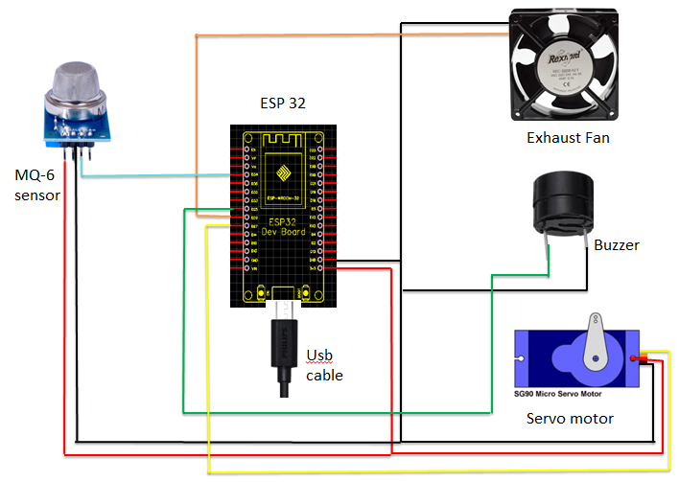

**Circuit Diagram :**

Microcontroller (ESP 32)

Sending Mail to the owner

Switch on the exhaust fan

**Material Details :**

**1. MQ6 Gas Sensor**

* Function: MQ6 is a semiconductor type gas sensor which detects the gas leakage. The sensitive material of MQ-6 is tin dioxide (SnO2). It has very low conductivity in clean air [4]. This Gas sensor not only has sensitivity to propane and butane but also to other natural gases, low sensitivity to cigarette smoke and alcohol. The MQ-6 gas sensor is shown in fig. 2. This sensor can also be used for detection of other combustible gas such as methane



**MQ-6 sensor**

* Features: High sensitivity to propane, butane, and LPG gases. It has a detection range of 200–10,000 ppm and operates on 5V.

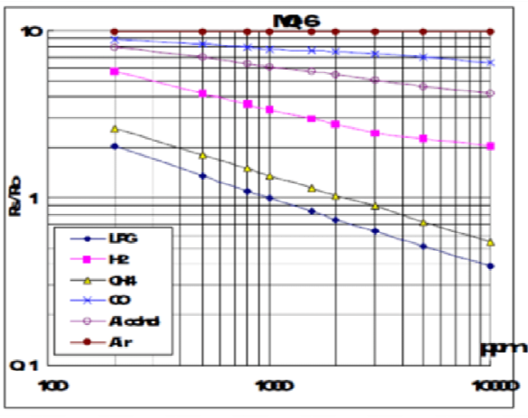

**Sensitivity of MQ6 gas sensor**

**2. ESP32 Microcontroller**

* Function: The ESP32 is the brain of the system, processing input from the MQ6 sensor and controlling various actuators such as the exhaust fan, buzzer, and servo motor. It also handles communication functions such as sending email notifications.
* Features: Equipped with Wi-Fi and Bluetooth, it has multiple GPIO pins, ADC for reading analog signals from the sensor, and is highly energy-efficient, making it ideal for IoT applications. It runs on 3.3V but can accept inputs from 5V sensors.

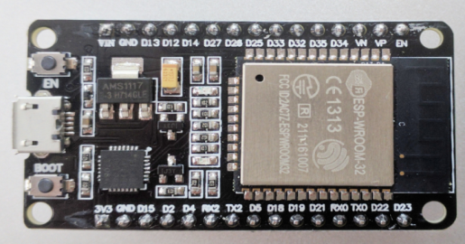

**ESP 32 (Microcontroller)**

**3. Exhaust Fan**

* Function: The exhaust fan is used to ventilate the area in case of a gas leak. It helps to disperse the leaked gas and prevent its accumulation, which could otherwise lead to an explosion.
* Control: The ESP32 activates the fan using a digital output pin.

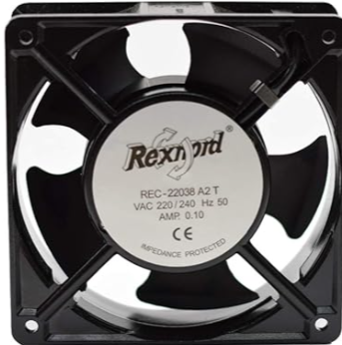

Exhaust fan

**4. Buzzer**

* **Function**: The buzzer provides an audible alert to warn people in the vicinity of a potential gas leak. The sound is loud and continuous until the system detects that the gas levels have returned to normal.
* **Control**: The buzzer is controlled by the ESP32 through a digital output pin.



Buzzer

**5. Servo Motor**

* **Function**: The servo motor is responsible for physically turning off the regulator knob of the LPG cylinder in case of a leak. It is programmed to rotate a specified angle to close the gas supply.
* **Control**: The ESP32 sends PWM (Pulse Width Modulation) signals to control the angle of the servo motor.

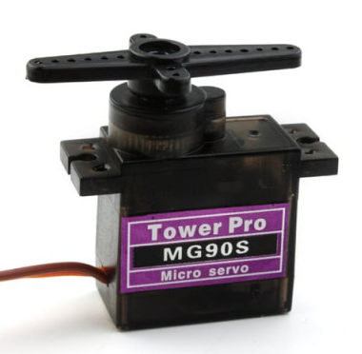

Servo Motor

1. **SMTP Service for Email Notification**

* **Function**: The ESP32 connects to the internet via Wi-Fi and uses an SMTP (Simple Mail Transfer Protocol) service to send email alerts in the event of a gas leak. The mail server details are configured in the code to send emails to pre-defined recipients, ensuring remote alerts. It also sends the value of leakage gas to the owner so that he/she can understand the amount of gas leakage and take action according to it .

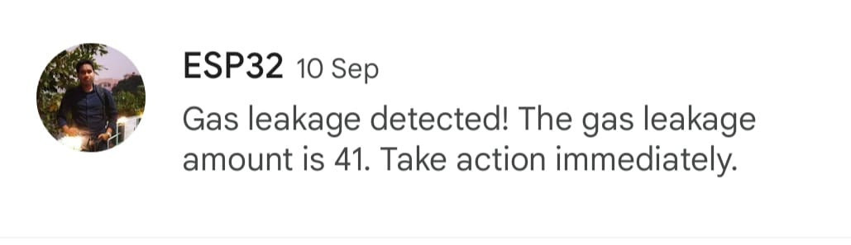

Screenshot of MAIL

**Results:**

The LPG gas leakage detection system based on the MQ6 sensor and ESP32 microcontroller produces several significant outcomes that enhance safety in environments where LPG is used. Here are the key results of this project:

1. **Accurate Gas Detection**:  
   The MQ6 sensor effectively detects LPG gas concentrations in the air. When the gas concentration surpasses the preset threshold, the system promptly identifies the leak and triggers necessary safety measures.
2. **Automated Ventilation**:  
   Upon gas detection, the ESP32 activates the exhaust fan via a relay, ensuring that the leaked gas is quickly dispersed from the environment. This reduces the risk of gas buildup, which could lead to fires or explosions.
3. **Audible Alert**:  
   A buzzer is immediately switched on, providing a loud warning to people nearby, allowing them to evacuate or take necessary action before the situation escalates.
4. **Automatic Shutdown of Gas Supply**:  
   The system uses a servo motor to physically rotate and close the cylinder regulator valve, cutting off the gas supply to prevent further leakage. This automatic control eliminates the need for manual intervention, adding a crucial layer of safety.
5. **Remote Notification**:  
   The ESP32 sends real-time email notifications to pre-configured recipients, alerting them to the leak even if they are not physically present. This feature is particularly useful for remote monitoring and enhances the overall reliability of the system.
6. **Improved Safety and Prevention**:  
   The multi-step response system greatly reduces the risk of accidents, injuries, or property damage by providing early warnings and automatic preventive actions in case of LPG gas leaks.

Overall, the project demonstrates a comprehensive, automated, and reliable gas leak detection system, making it an effective solution for both domestic and industrial settings.

**Application:**

The LPG gas leakage detection system has a wide range of applications across various sectors, providing enhanced safety in environments where LPG is commonly used. Here are some key applications:

**1. Domestic Kitchens:**

* This system can be installed in households to prevent potential hazards from gas leaks in kitchen areas. It automatically detects leaks and takes immediate action, protecting residents from fire and explosion risks.

**2. Commercial Kitchens:**

* Restaurants, hotels, and other food preparation businesses that use LPG for cooking can benefit from this system to ensure the safety of staff and patrons. It provides automated responses to leaks and reduces the risk of accidents.

**3. Industrial Settings:**

* Factories and industrial facilities that use LPG as a fuel source in production processes can deploy this system to safeguard against gas leaks, ensuring the safety of workers and preventing damage to equipment and infrastructure.

**4. LPG Storage and Distribution:**

* In storage facilities or distribution centers where LPG cylinders are kept, the system helps monitor for leaks, protecting assets and preventing potential accidents during transportation or storage.

**5. Hotels and Apartments:**

* For large residential complexes like hotels or apartment buildings, this system can be used to monitor centralized LPG supplies, ensuring the safety of all occupants by providing early warnings of leaks.

Overall, this LPG gas leakage detection system is essential in any environment where LPG is used, providing automated safety responses to reduce the risk of fire, explosions, or toxic exposure.

**Advantages:**

The LPG gas leakage detection system offers several key advantages that make it a highly effective safety solution:

**1. Real-Time Alerts:**

* The ESP32 microcontroller, with its Wi-Fi capabilities, sends real-time email notifications to users, allowing them to take action remotely. This feature is particularly useful when the occupants are away, ensuring continuous monitoring and safety.

**2. Cost-Effective:**

* The system uses readily available and affordable components such as the MQ6 sensor, ESP32, and relay modules, making it an economical solution for both domestic and industrial applications.

**3. Easy to Install and Operate:**

* The system is relatively easy to install and requires minimal maintenance. Once set up, it operates autonomously, making it user-friendly and efficient for long-term use.

**4. Energy-Efficient:**

* The ESP32 microcontroller is known for its low power consumption, making the system energy-efficient, especially for IoT-based applications that require continuous operation.

These advantages make the LPG gas leakage detection system a robust and reliable solution for enhancing safety in environments where LPG is used.

**Conclusion:**

In conclusion, the LPG gas leakage detection system based on the MQ6 sensor and ESP32 microcontroller provides an efficient, automated, and reliable solution for detecting and responding to gas leaks. The integration of multiple safety mechanisms—including exhaust fan activation, audible buzzer alerts, automatic shutdown of the gas regulator via a servo motor, and real-time email notifications—ensures a comprehensive approach to risk mitigation. The system not only detects LPG leaks with precision but also initiates immediate actions to minimize the dangers associated with gas accumulation, such as explosions or fires.

This project demonstrates the successful application of widely available sensors and components in creating an effective safety system. Its scalability and versatility make it suitable for both domestic and industrial environments, offering enhanced protection and peace of mind. The incorporation of remote notifications further extends the system's utility, making it a robust solution for modern smart safety applications.

**References:**

1. A Shrivastava, R Prabhaker, R Kumar, R Verma, "GSM based gas leakage detection system." International Journal of Emerging Trends in Electrical and Electronics, vol. 3, no. 2, pp. 42-45, 2013.